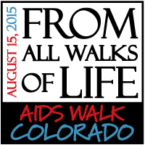

**Come out and walk with TEAM CHIP on Saturday,**

**August 15th!**

**What Is A Team?**  
**A team is a group of co-workers, students, friends and family members that pre-register, raise money as a group, and walk together on the day of AIDS Walk Colorado.**

**Walk registration is FREE!**

**Prizes will be rewarded to fundraisers who qualify! Come spend the day with us! Following the completion of the Walk & Run, the Celebration of Life Festival continues until 2:00pm and includes live entertainment, the Diva Dash Stiletto Fun Run, food, beverages and more!**

**Registration begins at 7:30am**

**Opening Ceremony & Walk starts at 9:00am**

**Cheesman Park, Denver**

**Visit** [**www.aidswalkcolorado.org**](http://www.aidswalkcolorado.org) **for more information and to join the CHIP team! If you register online, be sure to click “donate”, then “home”, then “view all teams” and choose “CHIP” from the drop down menu!**

**Email** [**chipteam@childrenshospital.org**](mailto:chipteam@childrenshospital.org) **or call 720.777.8730 for questions about registering and tips on how to fundraise for our team!**